Get Involved - Game Day
Nominate your school or club to be involved with Team Northumbria’s home games.
Match day mascots
Open to students aged 13 and under you can choose up to 12 young people to be one of our match day mascots. As a mascot you will
- Receive fantastic courtside seats behind the Northumbria players
- Before the games - mascots will have a tour of the facilities including where the TN players train, the sport science labs, gym, pool and media balcony
- Match time – mascots will support the players running out onto court and stay as part of the team huddle before leaving the court (a great chance for pictures)
- Half time – you will get the chance to play on court in games and activities led by netball volunteers or TN players
- After the game, mascots will be able to meet players and get their autographs
- Mascots will also receive a goodie bag including: Cheer sticks, lanyard and autograph sheet for players to sign

Ball Girls/boys
Open to students aged 11+, each club/school can nominate 4-8 young people to be one of our ball girls/boys. Ball girls and boys play a vital role in keeping the game flowing. You don’t need to have any prior experience as you will be given a full briefing before the match. We also provide you with a t-shirt to wear during the match which is then yours to keep.

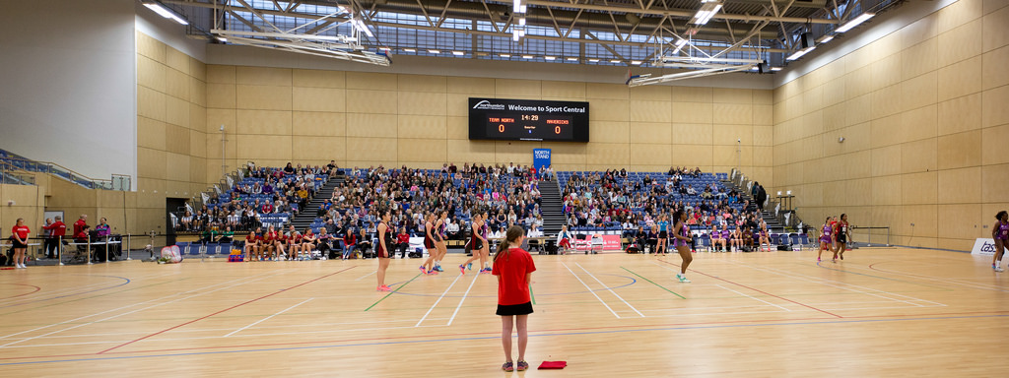

If you would like to nominate your club/school to be one of our match day mascots or ball girls/boys please number (1,2,3) your top three fixture preferences.
Name of Club/ School: ………………………………………………………………………………………………………
Contact number…….……………………………… Contact Email: ………………………………………………
Please circle - MATCH DAY MASCOTS BALL GIRLS/BOYS CONSIDER US FOR BOTH
Saturday 10th Feb (18:00) Team Northumbria vs Team Bath
Saturday 17th Feb 2018 (18:00) Team Northumbria vs Loughborough Lightning
Monday 5th March (19:45) Team Northumbria vs BencoMavericks
Saturday 17th March (18:00) Team Northumbria vs Surrey Storm
Saturday 21st April (18:00) Team Northumbria vs Severn stars
Monday 7th May (18.00) Team Northumbria vs Sirens
Saturday 12th May (18:00) Team Northumbria vs Manchester Thunder
Saturday 2rd June (18:00) Team Northumbria vs Celtic dragons
Saturday 23rd June (18:00) Team Northumbria vs Wasps

Please return this form to: Northumbria Sport, Pandon Building, Camden Street, Newcastle Upon Tyne, NE2 1XE Or email your preferences to: r.winbow@northumbria.ac.uk

The application deadline is
Sunday December 10th

