
Incident and Injury Record Form

The purpose of this form is to record all incidents and injuries.

Record of Incident or Injury (Please complete within 24hrs for all incidents)

Name of person completing this form: |  |  |  |  |  | Faculty/Service |  | Campus Services - Sport
Injured Person Details:
Surname: |  |  |  |  | Forename:
Faculty/Service:  Student number (If applicable): |  |  |  |  | Home Address:
Occupation: |  |  |  |  | Work/Home Tel:
Age: |  | Sex: M/F: |  |  | Line Manager Name & Tel:
Status (please circle): | Employee | Contractor |  | Student | Member of the public |  | Visitor |  | Other

Description of Incident/Injury
Exact Location of Incident/Injury:
(Building and area)
Date: |  | Time: |  |  | First Aider Name:
Description of Injury/Condition:

Type of Incident (circle as required) |  |  |  |  |  | Severity of Incident
Hazard or Near Miss | Injury |  | Ill Health | Other |  | Minor | Major | Fatal

Injury Type/Treatment
This section MUST be completed.  If no injury or damage occurred, record the incident as a near miss with no injury.  Where there is more than one injury, place a number on the part of the body affected and put the same number in the type of injury. Continue until all of the injuries are listed. | Body Map  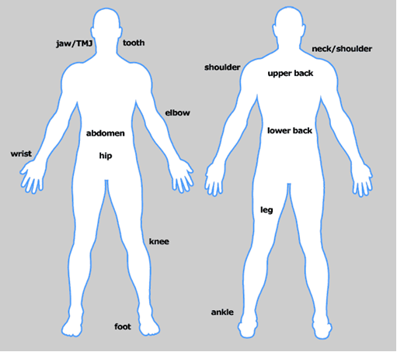 | Abrasion / Bruising
 |  | Amputation
 |  | Asphyxiation / poisoning
 |  | Burn / scald
 |  | Concussion / internal injuries
 |  | Dislocation
 |  | Electric Shock
 |  | Fracture
 |  | Lacerations / cuts
 |  | Loss of Sight / eye damage
 |  | Multiple Injuries
 |  | Natural Causes
 |  | Penetrating Injury
 |  | Respiratory distress
 |  | Sensitisation / irritation
 |  | Shock / stress
 |  | Sprain / strain
 |  | Superficial Injury
 |  | Other (please specify below)

Describe first aid treatment given:

Off-site treatment required: Yes/No
A&E/GP/Walk-in Centre/Returned to work/other (circle as necessary)
Has the incident area been made safe?  i.e. has the immediate danger/chance of escalation been removed | Yes/No/N/A

Describe briefly how the incident/injury occurred?
(Include events leading up to the incident. Use plans, photos, or diagrams as necessary) refer to attached guidance.

Describe any equipment/tools/substances being used at the time of the incident:

Incident type: tick as appropriate
 | Animals – Attack by |  |  |  | 1 |  |  | Machinery (Excluding Vehicles) |  |  |  | 19
 | Building/Scaffolding Collapse |  |  |  | 2 |  |  | Microbiological Release |  |  |  | 20
 | Burns |  |  |  | 3 |  |  | Other Causes |  |  |  | 21
 | Work Equipment Failure |  |  |  | 4 |  |  | Portable Power Tools |  |  |  | 22
 | Crushed |  |  |  | 5 |  |  | Radiation |  |  |  | 23
 | Dangerous Occurrence |  |  |  | 6 |  |  | Spillage of Chemicals/Harmful Substances |  |  |  | 24
 | Drowned |  |  |  | 7 |  |  | Sports Injury |  |  |  | 25
 | Electricity |  |  |  | 8 |  |  | Striking against Stationary Object |  |  |  | 26
 | Explosions |  |  |  | 9 |  |  | Struck by Moving Object |  |  |  | 27
 | Falls from Height |  |  |  | 10 |  |  | Traffic |  |  |  | 28
 | Falls on level – Slip/Trip/Stumble |  |  |  | 11 |  |  | Trapped |  |  |  | 29
 | Falls on Stairs |  |  |  | 12 |  |  | Near Miss |  |  |  | 30
 | Fires |  |  |  | 13 |  |  | Violence to Staff |  |  |  | 31
 | Hand Tools |  |  |  | 14 |  |  | Verbal Abuse |  |  |  | 32
 | Manual Handling |  |  |  | 15 |  |  | Nip |  |  |  | 33
 | Sharps |  |  |  | 16 |  |  | First Aid |  |  |  | 34
 | Contact with Harmful Substances |  |  |  | 17 |  |  | Ill Health |  |  |  | 35
 | Infectious Materials |  |  |  | 18
Northumbria Sport Use Only
User Type |  |  | Activity |  |  | Club/Team |  |  |  | Lead Person
Gym/Swim User
Group Exercise User*
Just HIRE
Just TRY*
Just PLAY*
Intramural*
Student Sport Club*
External Hires
External Event
Kids Camps*
Other (please specify)
*Activity organised and supervised by Northumbria Sport



APPENDIX 1 - Northumbria Sport Only

PLEASE COMPLETE ALL FIELDS IN BLOCK CAPITALS

To be used with all Sport and Activity related injuries in conjunction with the IR1 form

First Name Surname

Day Date

Activity Type PLEASE COMPLETE

a) |  | Core Services (Facilities)
 |  | Organised Activity
 |  |  |  |  | Activity Type (e.g. Group Exercise Class) |  | Location
 |  | Individual Activity
 |  |  |  |  | Activity Type (e.g. Swim) |  | Location
b) |  | Compete
 |  | Training Session
 |  |  |  |  | Sport |  | Location
 |  | Match
 |  |  |  |  | Sport |  | Location
 |  | Lead Person
 |  |  | e.g. Coach, Captain, Volunteer, Staff Member
c) |  | Sport Development
 |  |  |  |  | Activity Type Location
 |  | Lead Person
 |  |  | e.g. Coach, Captain, Volunteer, Staff Member

Indoors / Outdoors (please circle)

If outdoors, please tick one of the following Weather Conditions at the time of the Incident;
ground conditions: Tick all which apply

Hard |  | Frozen |  |  | Clear and Sunny |  |  |  | Cold
Soft |  | Snow |  |  | Overcast |  |  |  | Mild
Wet |  | Muddy |  |  | Raining |  |  |  | Hot
Icy |  | Normal |  |  | Snowing

